AWS TECHNICAL ESSENTIALS
Parts 1 & 2 — Study Notes
Cloud Practitioner Essentials — Exam Prep

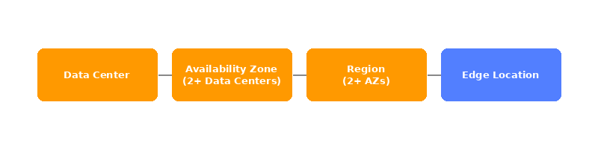

 MODULE 1 Introduction to Amazon Web Services

Core Infrastructure

  Data Center | A physical server facility. The smallest unit in AWS's global infrastructure.

  Availability Zone (AZ) | A cluster of 2 or more data centers. AZs are isolated from each other to prevent single points of failure.

  Region | A cluster of availability zones located in a geographic area. AWS has regions worldwide and you choose the one closest to your users.

  Edge Location | "Middle man" between the region and the user. A location where you can store small amounts of frequently used data you need to have ready for the user at all times (popular/mostly used data).

  API | The way to interact with AWS. Every interaction with AWS is an API call.

Ways to Interact with AWS

1. AWS Management Console — The most basic way, interacting through the main page in AWS.
2. CLI — A script you can schedule to do as you want. A simple way to automate the process of pulling up basic day-to-day resources and mundane tasks that need to be done.
3. SDK — SDK allows you to write code in one of the supported languages and interact with AWS through code. It lets you simply write your action into AWS.

⚠ WHAT YOU MISSED — Know This for the Exam
- 6 Advantages of Cloud Computing: 1) Trade upfront expense for variable expense. 2) Stop spending money on data centers. 3) Stop guessing capacity. 4) Benefit from massive economies of scale. 5) Increase speed and agility. 6) Go global in minutes. These 6 advantages are directly tested.
- IaaS vs PaaS vs SaaS: IaaS = EC2 (you manage OS and up). PaaS = Elastic Beanstalk (you manage code only, AWS handles the rest). SaaS = Gmail, Salesforce (vendor manages everything). Know which AWS services belong in each category.
- Cloud deployment models: Public cloud (everything on AWS). Private cloud (on-premises, you manage everything). Hybrid (mix of public + on-premises, connected via Direct Connect or VPN).
- Shared Responsibility Model: AWS = security OF the cloud (hardware, global network, hypervisors, physical security). You = security IN the cloud (your data, OS patching, IAM config, network settings). This is the single most tested concept in the Security domain.

 MODULE 2 Compute in the Cloud

IAM & Users

  Root User | The main user of the account, has access to every part of the account and is able to do as they please. Should be used as little as possible — create an admin IAM user instead.

  MFA | An authenticator app which gives a one-time code that is used to log into the AWS account, combined with the password and email address of the user while logging in to help make the account more secure and harder for unwanted personal to get into.

TIP | Best practice: Enable MFA on the Root User immediately. Never use the Root User for everyday tasks — create IAM users with only the permissions they need.

EC2 Instance Families

General Purpose — Balanced CPU/Memory/Network
- t series (t3, t4g) — burstable, cheapest, great for small apps/dev environments
- m series (m6i, m7g) — steady workloads, most common for production
General purpose instances provide a balanced mix of compute, memory, and networking resources. They are ideal for diverse workloads, like web services, code repositories, and when workload performance is uncertain.

Compute Optimized — High CPU Relative to Memory
- c series (c6i, c7g) — batch processing, gaming servers, high-traffic web servers
Compute optimized instances are ideal for compute-intensive tasks, such as gaming servers, high performance computing (HPC), machine learning, and scientific modeling.

Memory Optimized — High RAM Relative to CPU
- r series (r6i, r7g) — databases, caching (Redis), big data
- x series (x2idn) — extreme memory, SAP HANA, in-memory DBs
- u series — ultra-high memory (TBs of RAM)

Storage Optimized — High Local Disk I/O
- i series (i4i) — NoSQL databases, data warehousing
- d series — dense HDD storage, Hadoop
- h series — high disk throughput

Accelerated Computing — GPUs / Special Hardware
- p series (p4, p5) — ML training, HPC
- g series (g5) — ML inference, video rendering, gaming
- inf series (inf2) — AWS Inferentia chip, optimized for ML inference
- trn series — AWS Trainium chip, ML training

How to Read an Instance Name

Example: m6i.2xlarge
m → family (General Purpose)
6 → generation (newer = better price/performance)
i → processor modifier (Intel; a = AMD, g = Graviton/ARM)
2xlarge → size (more = more CPU, RAM, Network, EBS)

EC2 Pricing Models

  Spot Instances | Bid on spare compute capacity at up to 90 percent off the On-Demand price, with the flexibility to be interrupted when AWS reclaims the instance.

EC2 Instance Lifecycle

An EC2 instance transitions between different states from the moment you create it until its termination.

1. Pending — The setup for the EC2, you're not billed yet.
2. Running — It's ready to be used and is billing you. You can stop, reboot and shut it down now.
3. Reboot — It's like rebooting a computer. It saves all the data stored before and keeps the same public or private IP and host computer.
4. Stop — It's like closing down your laptop. It saves its IP address and last data stored on it BUT RAM is wiped — it will need a full OS boot next time it is started.
5. Stop Hibernate — The difference is that it's ready to open and resume without needing a full OS boot. RAM is stored in the EBS and restored from there.
6. Terminated — You cannot use the machine anymore, you will lose its IP, it will not bill you and all information on it is erased.

- Stop → most common, fine for servers/apps that boot fast and don't need state preserved
- Hibernate → useful when you have a long-running process or heavy in-memory state you want to resume quickly

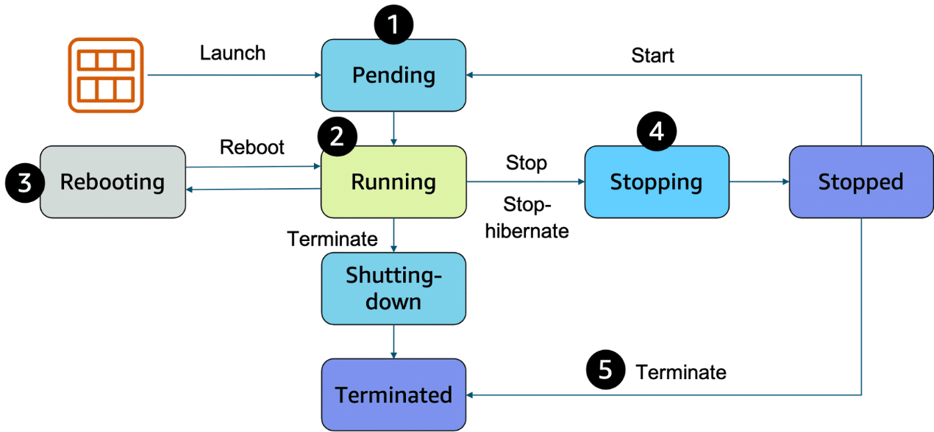

Decoupling Services

In modern application development, reliability and resilience are important. One effective way to achieve this is by adopting a service-oriented approach. These services help us do that:

  EventBridge | EventBridge is a serverless service that helps connect different parts of an application using events, helping to build scalable, event-driven systems. With EventBridge, you route events from sources like custom apps, AWS services, and third-party software to other applications. EventBridge simplifies the process of receiving, filtering, transforming, and delivering events, so you can quickly build reliable applications.

  Amazon SQS | Amazon SQS is a message queuing service that facilitates reliable communication between software components. It can send, store, and receive messages at any scale, making sure messages are not lost and that other services don't need to be available for processing. In Amazon SQS, an application places messages into a queue, and a user or service retrieves the message, processes it, and then removes it from the queue.

  Amazon SNS | Amazon SNS is a publish-subscribe service that publishers use to send messages to subscribers through SNS topics. In Amazon SNS, subscribers can include web servers, email addresses, Lambda functions, and various other endpoints.

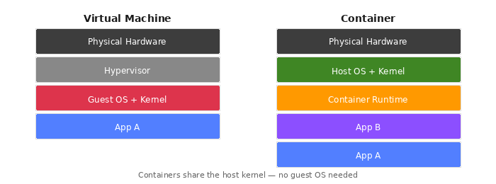

Containers & Serverless

  Virtual Machines / VM | A computer running in a data center you're connected to, like an EC2. They have a kernel and an OS system.

  Kernel | The base of an OS system and is installed on the VM. It is NOT installed in a container.

  Containers | A container is a way to package an application with everything it needs to run. It contains a mini runtime environment with its code, tools, images and more. It connects to the host computer and runs using Linux. It does NOT include a kernel and relies on the host to have one or a tool to install it.

💡 Analogy: Think of an apartment building: Kernel = the building's infrastructure (electricity, plumbing, elevators). Docker = the building manager (assigns apartments, sets rules). Container = a tenant (lives independently, but shares the building's infrastructure).

  ECS | A tool made for AWS to run containers on EC2, it is only on AWS and is simpler than EKS, it is also able to run on Linux and windows AMI. In ECS a container is called a task.

  EKS | The industry standard for running containers, it is an open source platform that is more popular and more complex and expansive than ECS. Containers running on it are called pods.

  ECR | A place to store container images, EKS & ECS both can pull from it.

  AWS Fargate | Fargate manages the EC2 scale and instances that way you can focus on the containers and uses of ECS & EKS.

  Lambda | A lambda is a function to which you can create triggers that will make sure that LAMBDA only starts to work when they are activated (like an if statement in coding). You only get billed for when it's used.

⚠ WHAT YOU MISSED — Know This for the Exam
- On-Demand vs Reserved vs Savings Plans: On-Demand = pay by the second, no commitment, most flexible. Reserved = 1 or 3 year commitment, up to 72% savings. Savings Plans = commit to $ spend/hour for 1-3 years, applies to EC2, Lambda, and Fargate. Reserved and Savings Plans require commitment — no switching mid-term for Standard RI.
- AMI (Amazon Machine Image): The template used to launch an EC2 instance. Includes the OS, storage mapping, architecture type, launch permissions, and any additional preinstalled software applications. You can create custom AMIs from existing EC2s and reuse them.
- Lambda limits: Max execution time = 15 minutes. Max memory = 10GB. Ideal for short, event-driven tasks — not for long-running processes.
- Fargate vs EC2 launch type: EC2 launch type = you provision and manage the underlying EC2 servers that run your containers. Fargate = serverless, AWS manages all infrastructure; you only define CPU and RAM per task.
- Dead Letter Queue (DLQ): A special SQS queue where failed/unprocessable messages are sent after a set number of failed attempts. Used for debugging and preventing message loss.

 MODULE 3 Global Infrastructure and Reliability

EC2 Auto Scaling & Load Balancing

The point of having load balancers is to make sure our workload is being balanced correctly and to mitigate problems that happen when it doesn't.

  ELB | AWS's main load balancer, ELB is used to balance any kind of load (instance or otherwise) in an application. It is highly available and scalable, as well as a health checker on your instances. When you create an ELB you must set a listener, whose job is to check for traffic and then route it to a healthy and not-busy instance. You must also create a target group — the place where you direct your traffic to. A rule helps associate a target group with a listener, it is made of two conditions: the source of the IP, and which target group to send the traffic to.

Type | Layer | Best For
Application Load Balancer (ALB) | Layer 7 | HTTP/HTTPS — routes based on request content
Network Load Balancer (NLB) | Layer 4 | TCP/UDP — routes based on IP protocol data
Gateway Load Balancer (GWLB) | Layer 3 | Third-party appliances — firewalls, IDS/IPS, deep packet inspection

  EC2 Auto Scaling | AWS allows us to create an auto scaling target group by creating a launch template in which you set the parameters for how the EC2 will work. The auto scaler creates new EC2 instances whenever the ELB and CloudWatch say the application is too stressed. The amount of EC2s and when to create them is available to change when you create the target group. They will also scale down once CloudWatch shows it isn't needed — all without human interaction.

Symptom | What to Scale
High CPU usage | Bigger size or compute-optimized (c family)
High RAM usage / swapping | Bigger size or memory-optimized (r family)
Slow network | Bigger size
Slow disk I/O | Bigger size or storage-optimized (i family)

TIP | It's better to start small then scale up if needed.

⚠ WHAT YOU MISSED — Know This for the Exam
- Horizontal vs Vertical scaling: Horizontal = add more instances (scale out — AWS preferred approach). Vertical = make the existing instance bigger (scale up). Auto Scaling always scales horizontally.
- Auto Scaling policies: Target Tracking = maintain a metric at a target (e.g., keep CPU at 50%). Step Scaling = add/remove in steps when alarm fires. Scheduled = scale at known times of day.
- Min / Max / Desired capacity: Minimum = floor, always keep at least X running. Maximum = ceiling, never exceed Y. Desired = the current goal Auto Scaling tries to maintain.
- CloudFront: AWS's CDN (Content Delivery Network). Caches content at Edge Locations worldwide to serve users faster. Works with S3, EC2, ELB, and integrates with Shield and WAF for security.
- Elastic Beanstalk: PaaS — you upload your code and Beanstalk handles the deployment, load balancing, auto scaling, and health monitoring automatically. Great for developers who don't want to manage infrastructure.
- CloudFormation: Infrastructure as Code (IaC). Define your AWS resources in a YAML or JSON template and CloudFormation provisions everything automatically. Enables repeatable, version-controlled infrastructure.

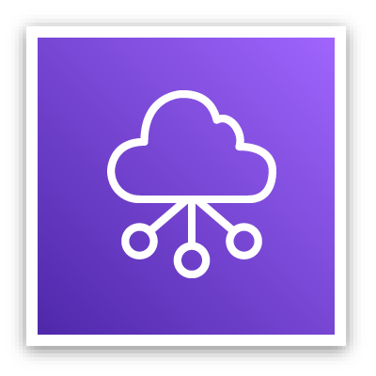 MODULE 4 Networking

IP Addressing

  IPv4 Notation | A decimal number built out of a 32 bit binary format IP address — 4 different binary numbers each one made of 8 1s & 0s.

  CIDR Notation | CIDR lets you express a range of IP addresses. It does that by putting a "/" before the flexible range — when you subtract the number after "/" from 32 you get the amount of flexible bits left in the address. The higher the number after "/", the smaller the amount of flexible bits.

VPC & Networking Components

  VPC (Virtual Private Cloud) | An isolated network that you can create in AWS, it mirrors a traditional network in a data center.

Subnets
There are two types of subnets in a VPC:
- Private — can only connect to the internet via NAT gateway, more secure.
- Public — can be connected to the net via an internet gateway.

  Internet Gateway | A way to connect the VPC and through it the public subnet on it to the net.

  Virtual Private Gateway | A way to connect your VPC to a private network (office, home etc.). It does require a physical device or software (AWS Direct Connect for example) on the customer side to let you use a VPN to connect to the VPG and through it to the VPC.

  AWS Direct Connect | A program by AWS that lets you connect your internal network such as home or office network to the VPC or AWS services.

  Main Route Table | When a VPC is created AWS creates a main route table with it to help route out the network traffic in and out of it. AWS on default allows traffic between all subnets in the local network. Rules: you cannot delete it OR replace it, you can add modify or delete routes in it, and you can change which subnets are associated with it.

  Custom Route Tables | If you want to change the route of flow to a subnet you can create a custom route table. Using it you are able to create different routes for the subnet, and if a route is created for a subnet it will use it instead of the main one, keeping the VPC more protected and organized.

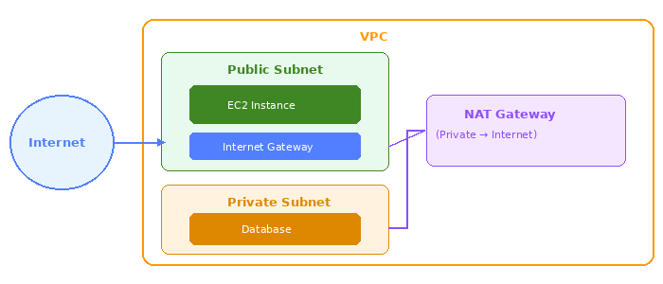

Firewalls

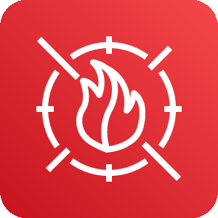  ACL (Network ACL) | The ACL acts as a cyber firewall around the subnets controlling what is allowed in and out. The default settings allows free flow with no restrictions. An ACL is stateless which means that when you configure it it's important to include inbound AND outbound gates so that traffic has a way of leaving the subnets once it's done.

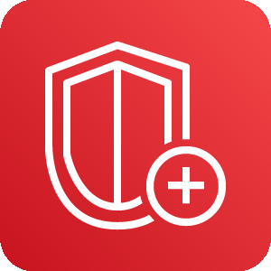  Security Groups | Just like ACL is for subnets, security groups does the same for EC2 — it acts as a firewall protecting and segregating an EC2. Because they are stateful unlike ACL you are allowed to create only an inbound port without creating an outbound one. Security groups block all inbound and outbound traffic on default.

Feature | Network ACL | Security Group
Level | Subnet level | EC2/Instance level
State | Stateless (need inbound + outbound rules) | Stateful (return traffic auto-allowed)
Default | Allows all traffic | Blocks all inbound traffic
Rule type | Allow AND Deny rules | Allow rules only

⚠ WHAT YOU MISSED — Know This for the Exam
- NAT Gateway: Allows instances in a PRIVATE subnet to initiate outbound internet connections (e.g., for software updates) while blocking all inbound connections from the internet. Sits in a public subnet and routes private subnet traffic out.
- VPC Peering: A networking connection between two VPCs that allows traffic to route between them using private IP addresses. Not transitive — A↔B and B↔C does NOT give A↔C connectivity.
- Elastic IP: A static public IPv4 address that you can associate with an EC2 instance. Without one, the public IP of your EC2 changes every time you stop and start it.
- Security Group default rule: Default inbound = BLOCK everything. Default outbound = ALLOW everything. You add specific inbound rules to open ports (e.g., port 443 for HTTPS, port 22 for SSH).
- Route 53: AWS's DNS service. Handles domain registration, DNS routing, and health checking. Routing policies: Simple, Weighted, Latency-based, Failover, Geolocation — each routes traffic differently based on different criteria.

 MODULE 5 Storage

Storage Types

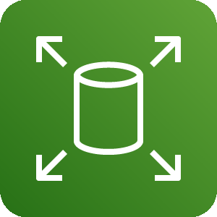  Block Storage | Block storage is built in a way that splits the file up into smaller blocks — thus any changes done to the file will be done on the smaller block and not the entire file. Because of that it is the perfect candidate for storing files that need to be changed a lot. Also good for storing containers because of their nature.

  Object Storage | Object is different than block in the way it organizes the file. In object the file is stored in the same form it is given without being cut or changed, that makes it better for files that need to be read a lot but changed little (WORM = Write once Read many). The object itself is stored in a bucket using a flat structure — unlike file storage there is no path or directories, each one has a unique identifier that is bundled with the rest of the data and is stored together.

  File Storage | File is our basic way of storing just like it is done on any normal computer, it works on folders and sub folders where each file has its own metadata like name, size and more. It also has a path that the system knows to make retrieving it easier when needed. Best used when you need a centralized storage system that is easy to share info through and can be used by multiple host computers.

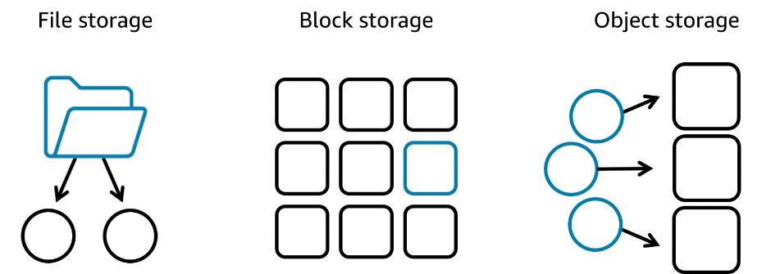
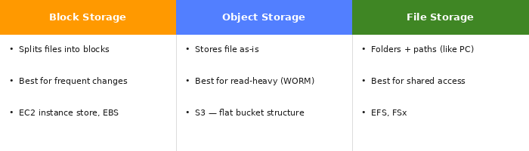

File Storage Services

  Amazon EFS | Amazon's app for file storage system, it can grow and shrink its storage size depending on its need. It has multiple storage classes like standard which works in multiple AZ zones, and one zone storage which works in only one AZ to make access easier.

  Amazon FSx | FSx works much like EFS but has compatibility with windows, higher performance such as using Lustre and is in general more compatible than EFS which is the main reason to use it.

EC2 Storage

  EC2 Instance Store | On every EC2 instance there is a storage attached, it is built like that so you can connect to the data faster and to keep high performance since it's all stored locally on the EC2. That means that if the instance is deleted the data is deleted with it.

  Amazon EBS | EBS is Amazon's solution to that problem, it acts as an external hard drive connected to the EC2 and stores its data for it. It can be detached from it and connected to another EC2 (all in the same AZ). It can even be attached to more than one EC2 instance.

EBS Scaling: 1. Increase volume size — goes up to 64 tebibytes. 2. Attach more than one EBS to a single EC2 — EC2 has a one-to-many relationship.
EBS Volume Types: SSD — used for more small size workloads and transactional work, easier for read/write operations. HDD — used for large streaming workloads that need high throughput performance.

  EBS Snapshots | A simple way to back up your EBS data, it only saves the latest changed info. For example if your 10 GB file had 2 GB changed, that 2 GB file will be saved into the snapshot ONLY. It is saved in a multiple AZ zone automatically by Amazon.

Object Storage — S3

  S3 | S3 is an object storage service which lets the user retrieve the data from anywhere, it isn't attached to an EC2 or VPC — it's completely accessible from the web. In S3 you store objects in Buckets, you can't upload anything to S3 without first creating a bucket. Buckets are per region so every name must be unique to not clash. S3 has many different storage classes with different uses as well.

  S3 Object Key | When creating an object in S3 you must give it a unique object key — since S3 is an object storage type all its info is in a flat structure using the key to find it.

⚠ WHAT YOU MISSED — Know This for the Exam
- S3 Storage Classes: S3 Standard (frequent access, highest cost). S3 Standard-IA (infrequent access, cheaper). S3 One Zone-IA (one AZ only, cheapest IA). S3 Glacier Instant/Flexible/Deep Archive (archival, lowest cost, retrieval from minutes to hours). Lifecycle policies auto-move objects between classes based on age.
- S3 Durability & Availability: 11 nines of durability (99.999999999%) — AWS virtually guarantees it won't lose your data. Standard availability is 99.99%. Durability = data won't be lost. Availability = data is accessible when you need it.
- S3 Versioning: Keeps multiple versions of an object in the same bucket. Protects against accidental deletion and overwrites. A deleted object gets a delete marker — you can recover it by removing the marker.
- EBS vs Instance Store: Instance Store = temporary, extremely fast, data is permanently lost when instance is stopped or terminated. EBS = persistent, survives instance stop, can be detached and reattached, supports snapshots.

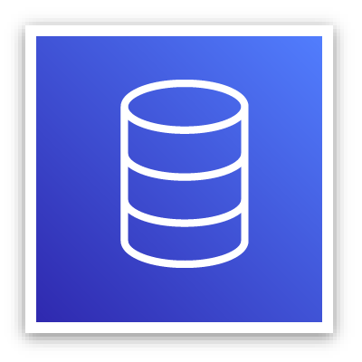 MODULE 6 Databases

TIP | Simple rule of thumb: If you can put it in a spreadsheet row → Database. If you'd save it as a file on your computer → Storage.

Database Concepts

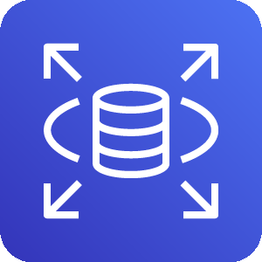  Relational Databases | The most popular option. A relational database organizes data into tables. Data in one table can link to data in other tables to create relationships — hence the relational part of the name. The relationship between the different parts of the table is called a logical schema. A schema becomes fixed once a database becomes operational, that's why the data modeling should be done before that.

  Unmanaged Database | An unmanaged database lets AWS have control only on the hardware. While you have to take care of the scaling, patches, availability and more.

  Managed Database | You can give most of the responsibility to AWS but that means less control over the database. It gives you the setup of both the EC2 instance and the database, and they provide systems for high availability, scalability, patching, and backups. This option provides the ultimate convenience but the least amount of control.

Database Services

  Amazon RDS | Amazon's way of having a managed database service in AWS, it supports multiple RDBMS and is built like an EC2 with instances which you need to assign a size and type. You deploy a DB instance in a VPC and then choose its dedicated subnet. Also available is the ability to deploy in multiple AZ zones which creates a copy of your DB instance in a different AZ and syncs it to the primary one to make sure info is saved in case of a crash. It is also connected to the EC2 instance and in case of a problem with the primary DB the EC2 will switch to moving info to it.

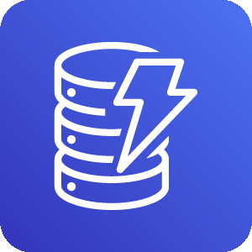  DynamoDB | Dynamo is the most popular option in AWS — it is a fully managed NoSQL database great for two categories of applications: high scale and serverless. It can create database tables that can store and retrieve any amount of data and serve any level of request traffic. Scale up or scale down tables' throughput capacity without downtime. Dynamo also stores your data in multiple AZ zones and all its data is stored on SSD so it's fast to pull. It also comes with the idea of creating IAM roles for security.

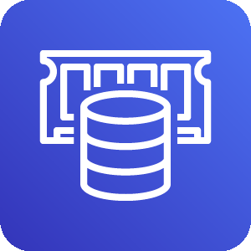  ElastiCache | Use when speed is critical and you don't need to store the data, it works on cache and along applications like RDS and aurora. When a user makes an API call to an EC2 it first checks the ElastiCache for the data stored there, if it isn't there then it goes to the database stores in ElastiCache and then sends to user. Good for keeping data that needs to be accessed fast and often made mainly for optimizing speed and data storing it does NOT replace databases.

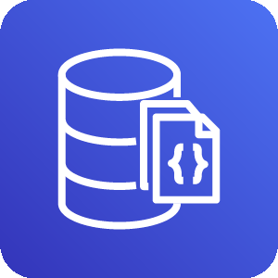  Amazon DocumentDB | The main feature in DocumentDB is that it is built for semi schema structure, which makes it way more flexible than Dynamo or RDS. For example, if one user has an email address and another a telephone number for contact, RDS is not able to use both since it is a fully structured schema. While Dynamo is semi structured as well it doesn't let you search and query inside the database like Document does AND is designed for simple look ups and for scale making it bad for complex searches. That is where Document shines, best at searching and querying while staying flexible at its nature.

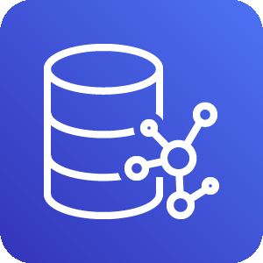  Amazon Neptune | Neptune is built to store data like a graph, while RDS stores it in a spreadsheet to keep track Neptune uses its graph feature as an advantage. Its graph is built from objects: Node = a thing (a person, a product, a place). Edge = the connection between things (follows, bought, lives in). Neptune's graph database makes it exceptionally good at complex relationships between objects, and great at scalability and high performance.

TIP: There are more databases available in AWS with different features for each application, it all depends on what you're looking for.

⚠ WHAT YOU MISSED — Know This for the Exam
- RDS Multi-AZ vs Read Replicas: Multi-AZ = a standby replica in a different AZ that takes over automatically if the primary fails. Purpose: high availability and failover — NOT for performance. Read Replicas = additional copies of the DB that handle read traffic. Purpose: performance and scale — NOT automatic failover.
- Aurora: AWS's own managed DB engine, compatible with MySQL and PostgreSQL. 5x faster than standard MySQL on RDS. Automatically replicates data 6 times across 3 AZs. Auto-scales storage up to 128TB. Only supports MySQL and PostgreSQL — that's the trade-off vs RDS.
- DynamoDB vs RDS — when to pick which: Choose DynamoDB when: data has no complex relationships, you need massive scale, you need serverless, schema changes often. Choose RDS when: you need SQL, data has complex joins and relationships, you need ACID transactions.
- ElastiCache engines: Redis = supports persistence, replication, complex data types (sorted sets, lists). Memcached = simpler, multi-threaded, no persistence. Redis is more feature-rich; Memcached is simpler and faster for basic caching.

 MODULE 7 Security

Authentication & Authorization

Authentication is the process of verifying the identity of a user or entity through credentials like a username and password combination. Use case: An employee logs in to an employee portal.

Authorization grants users certain access rights and permissions that determine which actions they can perform in a system or application. Use case: An employee can only access their own employee records inside the employee portal.

  IAM Roles and Users | IAM lets you create different roles and users to keep your application secured and protected, roles are temporary and give specific access just for the time needed for that user or function. While users are permanent and can be grouped which makes it much easier to keep track and helps secure your application.

Additional Access Management Services

  AWS IAM Identity Center | IAM Identity Center centralizes identity and access management across AWS accounts and applications. IAM Identity Center can also connect to an existing identity source and provide your workforce with single sign-on access to all your connected AWS services and accounts. This is called federated identity management.

Federated identity management is a system that allows users to access multiple applications, services, or domains using a single set of credentials.

  AWS Secrets Manager | Secrets Manager provides a secure way to manage, rotate, and retrieve database credentials, API keys, and other secrets throughout their lifecycle. This helps keep your applications, services, and IT resources safe.

  AWS Systems Manager | Systems Manager provides a centralized view of nodes across your organization's accounts and Regions and multi-cloud and hybrid environments. With this service, you can quickly access node information, such as ID and operating system details, and automate registry edits, user management, and security patching. Its main use is running patches and keeping inventory of your EC2s and other applications.

Nodes are connection points in a network, system, or structure.

Network & Application Attacks

  DOS Attack | In a denial of service attack, an attacker floods a web application with excessive network traffic. Legitimate customer requests are denied if the web application becomes overloaded and can no longer respond.

  DDoS Attack | In a distributed denial of service (DDoS) attack, an attacker can use multiple infected computers (called zombie bots) to unknowingly send excessive traffic to a web application.

  AWS Shield | AWS Shield Standard is designed to automatically protect AWS customers from the most common, frequently occurring types of DDoS attacks at no cost. It uses a variety of analysis techniques to detect and mitigate incoming malicious network traffic in real time. AWS Shield Advanced is a paid service that provides detailed attack diagnostics and the ability to detect and mitigate sophisticated DDoS attacks. It also integrates with other services, such as Amazon CloudFront, Amazon Route 53, and ELB.

  AWS WAF | AWS WAF is a web application firewall that monitors network requests that come into your web applications. When a request comes into AWS WAF, it checks the IP address against a web access control list (web ACL). If the request comes from a blocked IP address on the web ACL, AWS WAF denies access. Legitimate requests are allowed access.

TIP | Shield and WAF will usually work together with Shield protecting against common DDoS and someone trying to overwhelm your app, and WAF protecting against exploiting.

Data Encryption

Data encryption works like a lock and key mechanism. If you have the right key, you can access the encrypted data. Otherwise, you cannot access the data.

Data encryption at rest: The data is idle and not moving, like when it's stored in a database.
Data encryption in transit: The data is moving between locations, like when it's being sent from a database to an application. SSL/TLS certificates are used to establish encrypted network connections from one system to another.

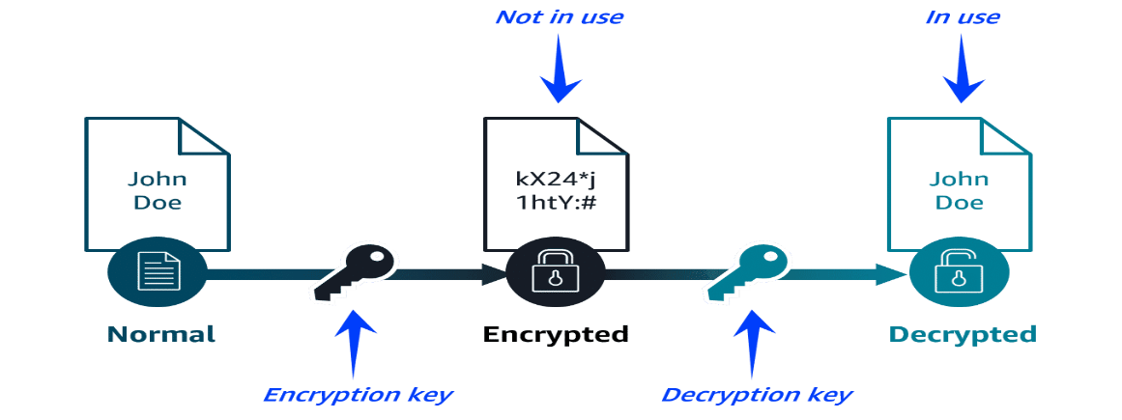
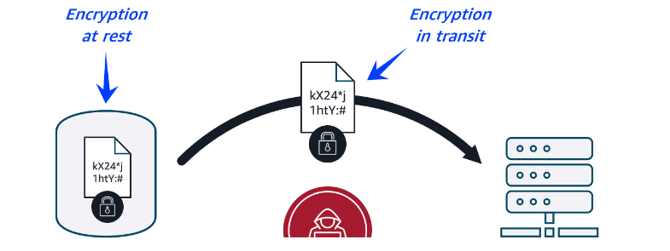

  AWS Key Management Service (KMS) | You can use AWS KMS to create and manage cryptographic keys. These keys can then be used to encrypt and decrypt your data. You can also control the use of keys across a wide range of services and in your applications. For example, you can specify which IAM users and roles can manage keys. Your keys never leave AWS KMS, and you can temporarily disable them so they can no longer be used.

Cryptographic key: a random string of digits used for locking (encrypting) and unlocking (decrypting) data.

  AWS Certificate Manager (ACM) | ACM centralizes the management of your SSL/TLS certificates that provide data encryption in transit. It can be used to protect various AWS services and your connected on-premises resources.

SSL/TLS certificates are used to establish encrypted network connections from one system to another.

⚠ WHAT YOU MISSED — Know This for the Exam
- IAM Groups: A collection of IAM users. Attach a policy to a group and every user in the group gets those permissions. A user can belong to multiple groups. Much easier than managing permissions for each user individually.
- Principle of Least Privilege: Always grant only the minimum permissions required to do a job — nothing more. This is a core IAM best practice and frequently tested on the exam.
- Root User restrictions: Only the root user can: close the AWS account, change the support plan, restore IAM admin permissions, change account settings. For everything else, use IAM users.
- Amazon GuardDuty: A threat detection service that continuously monitors your AWS accounts and workloads for malicious activity and unauthorized behavior. Uses ML to identify unusual API calls, unusual network traffic, and known malicious IPs.
- Amazon Inspector: Automated security assessment for EC2 instances and container images. Checks for known software vulnerabilities and unintended network exposure. Reports findings with severity ratings.

 MODULE 8 Monitoring and Analytics

CloudWatch

  CloudWatch | AWS's main app for monitoring EC2s and applications. Its main job is to collect data and create statistics for you to use all while monitoring your applications. You can use CloudWatch to create custom matrices and even alarms to alert you in case something goes wrong.

Alarm States
State | Meaning
Insufficient Data | Doesn't have enough metrics yet to decide — needs more time to collect.
OK | The metrics are inside the defined threshold.
In Alert | The application's metrics are out of the defined threshold.

TIP | You can define an action for when an alarm is triggered, like sending an alert or email. Or program it to automatically fix a technical issue, like rebooting an EC2 instance or using a Lambda function.

AI And Machine Learning AND Data Analytics

The AWS AI/ML stack is composed of the following three tiers of solutions:
1. AI Services — Pre-built models that are already trained to perform specific functions.
2. ML Services — A more customized approach with Amazon SageMaker AI where you build, train, and deploy your own ML models with fully managed infrastructure.
3. ML Frameworks and Infrastructure — A completely custom approach to building models using purpose-built chips that integrate with popular ML frameworks.

Deep learning — a way to teach AI models, it works on teaching them using layers of artificial neurons that mimic a human brain, each layer feeds the next until the final one.

FM — an AI model trained on vast amounts of data and is built to do multiple tasks at the same time, examples: Claude, ChatGPT.

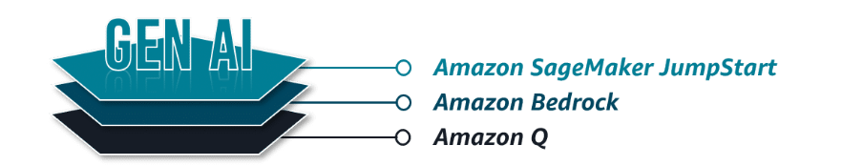
  Amazon SageMaker | JumpStart — An ML hub with FMs and pre-built ML solutions deployable with a few clicks. Build and train your own ML model faster.

  Amazon Bedrock | A fully managed service for adapting and deploying FMs from Amazon and other leading AI companies. Use someone else's powerful FM via API.

  Amazon Q | An interactive AI assistant that can be integrated with a company's information repositories. AI assistant for your business or your code.

Simple summary: JumpStart → build and train your own ML model faster. Bedrock → use someone else's powerful FM via API. Q → AI assistant for your business or your code.

ETL & Data Pipelines

ETL — ETL which is a process where you extract the data from different sources, then you transform it into a useable format, and then you load it into its destination. We do that using data pipelines.

Data pipelines are automated assembly lines used to make the ETL process efficient and repeatable.

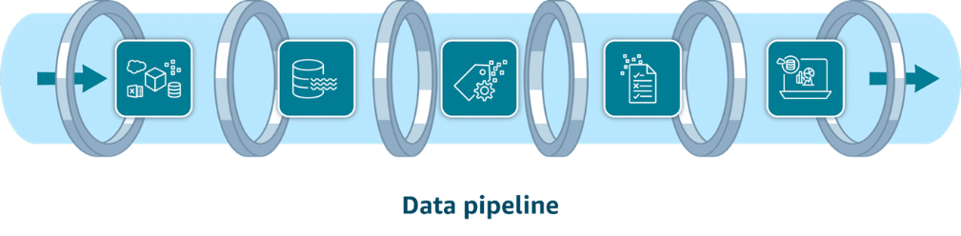

1. Data Ingestion Services
  Kinesis Data Streams | You can use Kinesis Data Streams for real-time ingestion of terabytes of data from applications, streams, and sensors. This serverless service even provides automatic provisioning and scaling in on-demand mode.

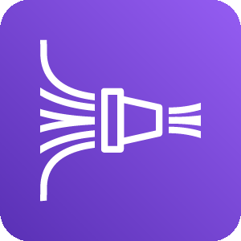  Amazon Data Firehose | Firehose is an option for data ingestion in near real-time. This fully managed service provides automatic provisioning and scaling. It also delivers data within seconds to data lakes, warehouses, and analytics services.

The key difference: Kinesis Streams is for when you need to do something with the data in real time. Firehose is for when you just need to move the data somewhere reliably.

2. Data Storage Services
  S3 (Data Lake) | Amazon S3 is a popular choice for data lakes. This object storage service can securely house virtually any amount of structured or unstructured data. Amazon S3 is also fully elastic, automatically scaling as you add and remove data.

  Amazon Redshift | Redshifts work similar to an RDS but for analytics. While RDS is built for complex relationships, Redshift is built to analyze and query huge amounts of historical data. It is a data warehouse analytics can pull from.

In a real pipeline they work together: Data lands in S3 first (cheap, flexible, keeps raw data) → Glue or Firehose transforms and loads it into Redshift → Business analysts run SQL queries on Redshift for reports and dashboards. So S3 is the lake where everything is stored cheaply, and Redshift is the engine where you actually analyze it.

3. Data Cataloging Services
  AWS Glue Data Catalog | AWS Glue Data Catalog provides a centralized, scalable, and managed metadata repository that enhances data discovery. It improves the overall efficiency of data pipelines by delivering metadata to various data stores and analytics services.

4. Data Processing Services
  AWS Glue | Glue's job is to clean the data as part of the ETL process. Its second feature is data cataloging, it maps out that same data before sending it forward giving the next function a "map" of the data to make it easier to use.

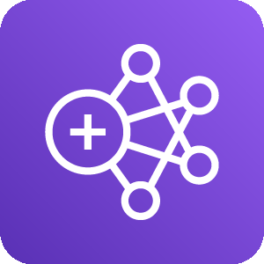  Amazon EMR | Amazon EMR is ideal for large-scale data processing and organizations with existing big data expertise. It automatically handles infrastructure provisioning, cluster management, and scaling. Amazon EMR supports popular big data frameworks like Apache Spark, Apache Hadoop, and Apache Hive.

5. Data Analysis and Visualization Services
  Amazon Athena | With Athena, you can run SQL queries to analyze data in relational, nonrelational, object, and custom data sources. This fully managed serverless service can access data hosted on Amazon S3, on premises, or even in multi-cloud environments. It offers a cost-effective solution for data analysis because you only pay for the queries you run.

  Amazon Redshift (Analytics) | Amazon Redshift is a fully managed data warehouse solution. Its columnar storage and massively parallel processing architecture make it ideal for analyzing large datasets. You can use it to perform complex SQL queries on large datasets for frequent, high-performance analytical workloads.

  Amazon QuickSight | With QuickSight, both technical and non-technical users can quickly create modern interactive dashboards and reports from various data sources without managing infrastructure. Amazon Q in QuickSight provides natural language queries. It is the main tool for visualization in AWS.

  Amazon OpenSearch Service | With OpenSearch Service, you can search for relevant content through precise keyword matching or natural language queries. Unified dashboards provide real-time data visualization as you analyze and monitor logs, traces, and metrics for various applications.

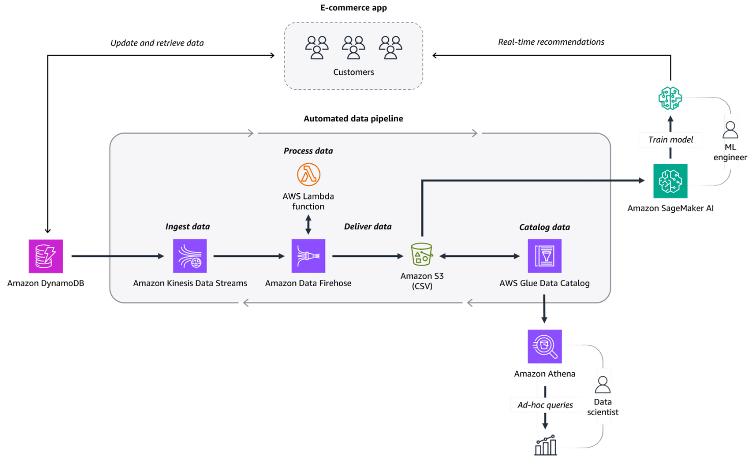

⚠ WHAT YOU MISSED — Know This for the Exam
- CloudWatch Logs: CloudWatch can also collect and store log files from EC2, Lambda, CloudTrail, and other services. You can create Metric Filters on logs to extract numerical data and trigger alarms from log content.
- Glue Crawlers: Glue Crawlers automatically scan your data stores (S3, RDS, etc.), detect the schema, and update the Glue Data Catalog — saving you from having to define metadata manually.
- Athena cost model: Athena charges per query based on the amount of data scanned. Use columnar formats (Parquet, ORC) and partitioning to scan less data and dramatically reduce costs.

 MODULE 9 Compliance and Governance

Monitoring for Compliance

To monitor your resources in an effective way in AWS you will need to provide insight into how they work, why they work and the problems that come with them. The progress you usually want for an effective monitoring is:
- Securing systems — making sure they are safe
- Monitoring activities — observing and analyzing them to detect problems
- Conducting audits — once in a while check that everything is working well and secure
- Ensuring compliance — make sure your security and efficiency meets the standards needed

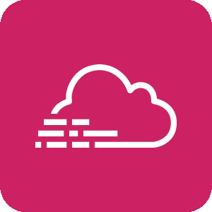  AWS CloudTrail | CloudTrail tracks user activity and API usage in the AWS Cloud, on premises, and even with other cloud providers. CloudTrail provides a detailed history of API calls, so you can track changes and identify who made them and when. This helps you understand what actions were taken on your AWS resources. Benefits: CloudTrail provides auditing, security monitoring, and operational troubleshooting. It also helps you prove compliance and improve your security posture.

Compliance

Compliance refers to your cloud resources and data adhering to relevant regulations, industry standards, and internal policies regarding security and data protection. AWS helps you keep your projects compliance by:
- Inheriting the latest security controls that AWS uses on its own infrastructure
- Third-party validation for thousands of global requirements
- Streamlining and automating compliance
- On-demand compliance reports

  AWS Artifact | The main tool on AWS to keep your projects in check with the compliance needed in your region. It offers compliance reports that way you can scale your applications infrastructure without worrying about its compliance with industry standard or the law.

  AWS Config | AWS Config is a service that you can use to assess, audit, and evaluate the configurations of your AWS resources. Benefits: AWS Config helps evaluate configurations against a desired state, manage resource configuration changes, and simplify troubleshooting and remediation.

  AWS Audit Manager | Audit Manager is a service that continually audits your AWS usage to simplify risk and compliance assessment. It helps collect evidence and manage audit data. Benefits: Audit Manager saves time with automated evidence collection, streamlines collaboration across teams, and helps ensure integrity of audits with read-only permissions.

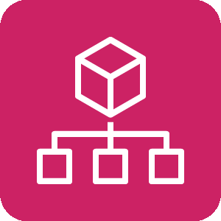  AWS Organizations | Organizations helps you centrally manage and govern your environment as you grow and scale your AWS resources. It helps you manage policies for groups of accounts and automate account creation. You choose a main account and all other accounts are considered secondary, all bills go to the main account for easier organization. Organizations also allows you to group accounts for easier access and management, you can assign each group its own policy's and restrictions which will help keep the project tidy. You can only assign policy's to users accounts or groups (OU).

Governance

As your operations scale you will need to keep track and to make sure your framework and policies are good enough to build on and adhere to your project.

  AWS Control Tower | Control tower is our main tool in AWS for governance. It has two main features: The first is guard rails — in control tower you're able to create rails to make sure there will be no resource misuse and to alert you to any problems that may happen. The second feature is account factory, it is similar to EC2 launch template and allows you to quickly config an AWS account for use that way you can scale quickly and efficiently.

  AWS Service Catalog | Helps you create quick starts for account by having the ability to create and use templates for programs that are used in AWS such as roles, DBs, S3 and more. If Control Tower creates the account quickly catalog fills it with what it needs to function.

  AWS License Manager | License Manager is a service that helps you manage your software licenses and fine-tune your licensing costs. Benefits: License Manager helps with visibility and control, tracking and managing licenses, and reducing the risk of noncompliance with licenses.

Other Helpful Programs

  AWS Health Dashboard | Your main check program for making sure the health of your AWS accounts and the programs in them are healthy and are problem free.

  Trusted Advisor | AWS helpful and constant adviser, it helps evaluate your application and gives advice on how to run it more efficiently and cheaper, its main goal is to help optimize your application and work.

  IAM Access Analyzer | IAM Access Analyzer provides capabilities to set, verify, and refine permissions by analyzing external access and validating that your policies match your corporate security standards. Benefits: IAM Access Analyzer provides benefits like refining permissions, validating IAM policies, helping you meet your least privilege goals, and automating IAM policy reviews.

⚠ WHAT YOU MISSED — Know This for the Exam
- CloudTrail vs CloudWatch — key distinction: CloudTrail = WHO did WHAT and WHEN (audit log of every API call made in your account — who deleted the S3 bucket?). CloudWatch = HOW is the system performing right now (CPU, memory, request counts, alarms).
- AWS Config vs CloudTrail: Config = what state is my resource in NOW, and did it change from my desired state? CloudTrail = who made the API call that changed it? Config detects drift; CloudTrail shows who caused it.
- Organizations SCPs (Service Control Policies): SCPs are permission guardrails applied to entire accounts or OUs. Even if an IAM user in a member account has AdministratorAccess, an SCP can block them from doing specific actions. SCPs define the maximum permission boundary.
- Trusted Advisor 5 pillars: Trusted Advisor checks across 5 categories: Cost Optimization, Performance, Security, Fault Tolerance, and Service Limits. Free tier includes 7 core security checks. Business/Enterprise support unlocks all checks.

 MODULE 10 Pricing and Support

Pricing Concepts

1. Pay as you go — With pay as you go, you can adapt to changing business needs and reduce the risk of overprovisioning or missing capacity.
2. Save when you commit — For certain services, such as Compute services on AWS, Savings Plans offer savings over On-Demand prices when you commit to a 1-year or 3-year plan.
3. Pay less by using more — With AWS, you can realize important savings as your usage increases. For some services, pricing is tiered — the more you use, the less you pay.

Driving Factors of Cost

1. Compute — For compute resources, you pay by a certain span of time, like by the hour or by the second. Unless you've made a reservation for which the cost is agreed upon beforehand, you pay from the time you launch a resource until the time you stop the instance.
2. Storage — Pricing for storage largely depends on how much storage you have provisioned or how much you are using. For some storage options, such as Amazon S3, storage cost is tiered — you can optimize storage costs based on how frequently and quickly you need to access data.
3. Data Transfer — In most cases, there is no charge for inbound data transfer or for data transfer between AWS services within the same Region. Outbound data transfer is aggregated across services and then charged at the outbound data transfer rate. The more data you transfer, the less you pay per gigabyte.

AWS Pricing and Billing Services

  AWS Organizations | AWS Organizations provides centralized management and governance of your AWS environment. Using AWS Organizations, you can create, group, and manage accounts. You can also apply security policies at the account level and consolidate billing with multiple accounts using a single payment method. Use cases: Consolidate multiple AWS accounts into one central organization. Implement organization-wide policies.

  AWS Billing and Cost Management Dashboard | The AWS Billing and Cost Management dashboard centralizes cost management, showing current charges, usage, forecasts, and detailed breakdowns. It also provides tools to manage payments, view invoices, set budgets, and consolidate billing. Use cases: Use helpful visualizations and billing reports of monthly AWS spend. Set up and manage payment methods.

  AWS Budgets | AWS Budgets helps set custom budgets and sends alerts when costs, usage, or Savings Plans and Reserved Instances (RIs) utilization or coverage exceed defined thresholds. Use cases: Set up alerts for when projected costs exceed predefined thresholds. Forecast future expenses based on current usage trends.

  AWS Cost Explorer | AWS Cost Explorer helps visualize, analyze, and manage AWS costs and usage with interactive graphs, reports, and forecasts. It provides insights into spending patterns, trends, and Reserved Instance recommendations. Use cases: Analyze historical spending trends to identify cost-saving opportunities. Forecast future AWS costs based on current usage patterns to budget effectively. More of a long-term analyzer compared to billing and cost management dashboard.

  AWS Pricing Calculator | A web-based planning tool that you can use to create estimates. You input specific configurations such as instance types, storage options, and data transfer volumes. Then, based on your configurations, you receive a detailed cost breakdown to help you budget for your AWS resource allocation. Use cases: Estimate potential costs before deployment. Compare costs of different AWS services and configurations.

Types of AWS Support

1. Basic support — The basic and all accessible support plan for AWS, available for everyone who uses AWS automatically. Includes the basic package and customer support, great for startups and small businesses.
2. Developer support — Includes the same as Basic BUT with added email support and better response time from customer support of 24 hours OR 12 when down.
3. Business support — Includes everything from before with an added full set of Trusted Adviser and really fast response time of 4 hours OR 1 when down.
4. Enterprise support — Includes everything from before with a designated technical account manager and a full set of AWS trusted advisers for help, as well as 15 min response time.

AWS Marketplace

The AWS Marketplace is a digital catalog that includes thousands of software listings from independent software vendors. The marketplace has many services like:
- Software as a service
- Machine learning (ML) and AI
- Data and analytics

⚠ WHAT YOU MISSED — Know This for the Exam
- AWS Free Tier — 3 types: Always Free = services that are always free regardless of time (e.g., Lambda 1M requests/month forever). 12 Months Free = free for 12 months after AWS signup (e.g., EC2 t2.micro 750hrs/month). Trials = short-term free trials of specific services (e.g., Amazon Inspector 90-day trial).
- Total Cost of Ownership (TCO): TCO compares the full cost of running workloads on-premises vs in the cloud. Factors include hardware, power, cooling, facilities, and IT staff. Cloud usually wins on TCO at scale because AWS provides economies of scale you can't match alone.
- Consolidated Billing benefit: AWS Organizations consolidated billing means all member accounts' costs roll up to the management account. The key benefit beyond simplicity: volume pricing discounts apply across the whole organization. If one account uses 1TB of S3 and another uses 1TB, together they get tiered pricing for 2TB.
- Support plan comparison — exam tip: Know which features come with which tier. TAM (Technical Account Manager) = Enterprise only. Full Trusted Advisor checks = Business and above. 24/7 phone/email/chat support = Business and above. 15-minute response time = Enterprise only.

 MODULE 11 Migration

Three Phases of Migration

1. Assess — In this phase, you build the business case for the migration and assess your readiness. One of the services used in this phase is the Migration Evaluator.
2. Mobilize — In this phase, you prepare the organization and mobilize the resources needed for the migration. Two services you might use in this phase are AWS Application Discovery Service and the AWS Migration Hub.
3. Migrate — In this phase, you use your strategy, plan, and the best practices to migrate.

  AWS CAF | The AWS CAF is a framework that brings AWS experience and best practices to companies preparing to migrate to the AWS Cloud. The framework provides tools to help accelerate the migration journey, organize resources, and align management during the transition. Benefits: AWS CAF provides benefits for migrations to reduce business risk and improve sustainability and corporate transparency. They can reduce operational costs, increase productivity, and improve customer experience in their new cloud environment.

Migration Strategies — The 7 Rs

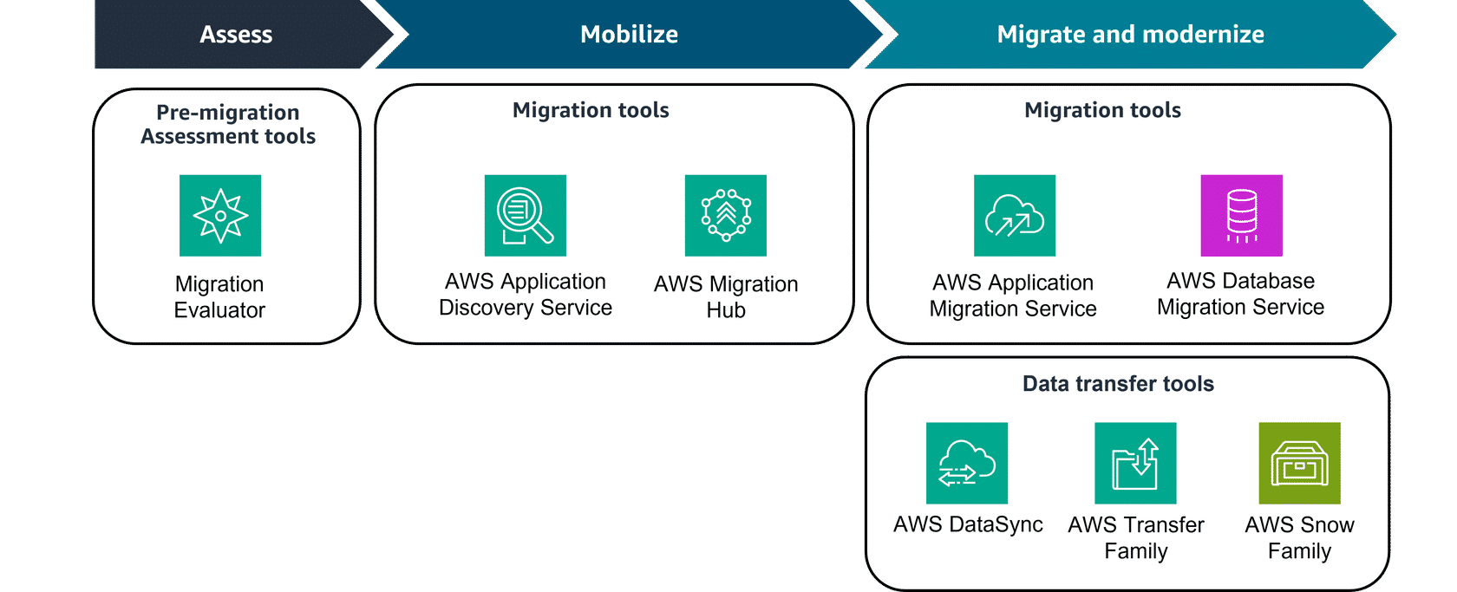
# | Strategy | Also Called | Description
1 | Rehost | Lift and Shift | Moving your application to AWS without changing them in any way. Great for small scale or fast change.
2 | Replatform | Lift, Tinker & Shift | The same as rehost only with the added change of optimization, no added code or change of core code.
3 | Relocate | Hypervisor-level lift | Possible if application is already a virtual machine. Changes the hosting location to the cloud.
4 | Refactor | Re-architect | The reimagining of an application to make it possible to move it to the cloud. Great in cases where you know you will need to scale up or improve performance.
5 | Repurchase | Drop and Shop | The change of a software vendor to a cloud-based one.
6 | Retain | Revisit Later | The choice to not move some services to the cloud — too costly, important to keep running, or not ready to be retired soon.
7 | Retire | Remove | Removing an application since it will not be needed anymore in the cloud.

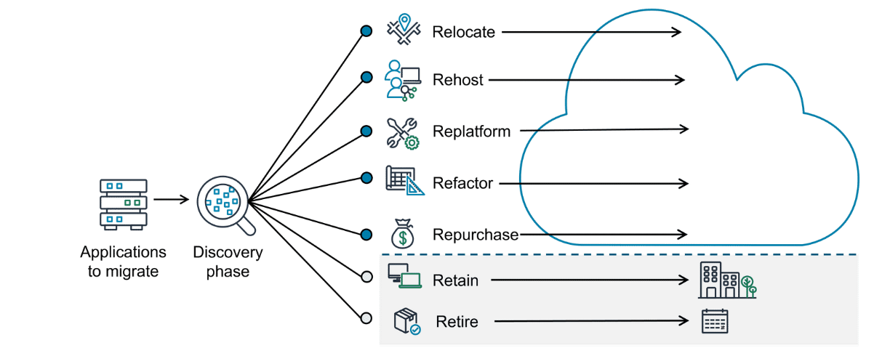

Migration Services and Tools

Assess Phase
  Migration Evaluator | The Migration Evaluator is a migration assessment service that helps you create a business case for AWS Cloud planning and migration. It does this with a data driven approach, analyzing your current state, target state, and developing a migration readiness plan with projected cloud costs. Benefits: removing the guesswork when migrating, visibility into multiple cost-effective cloud migration scenarios, insights on reusing existing software licensing.

Mobilize Phase
  Application Discovery Service | The Application Discovery Service discovers on-premises server inventory and connections. It gathers configuration, performance, and connection details for both servers and databases to create a detailed migration plan. Benefits: comprehensive snapshot of your on-premises inventory, integration with Migration Hub.

Migrate and Modernize Phase
  Application Migration Service | Application Migration Service is a tool to move and improve your on-premises and cloud-based applications. It helps customers streamline, expedite, and reduce the cost of migrating and modernizing applications. Benefits: support to migrate from any source infrastructure that runs a supported OS. You can maintain normal business operations during the application replication process.

  Migration Hub | The Migration Hub is a centralized hub to take you from discovery, assessment, planning, and execution of your migration. It provides tools, guidance, and automated recommendations to collaborate with your team and track your migration. Benefits: one location for your migration, expert guidance in the form of prescriptive journey templates. No charge to use Migration Hub.

Migrating Databases

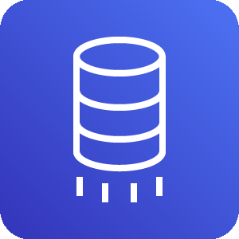  DMS (Database Migration Service) | The AWS Database Migration Service (AWS DMS) makes it possible to quickly and securely migrate databases and perform ongoing data replication tasks for live databases and data warehouses. Benefits: maintaining high availability and low downtime during the migration process. It supports homogenous and heterogeneous migrations. It also makes it possible to migrate terabyte sized databases at a low cost.

  SCT (Schema Conversion Tool) | AWS SCT makes it possible to convert database schemas and code objects (like stored procedures, views, and functions) from one database engine to another. AWS SCT can even give you estimates of how big of an effort a conversion is, which helps with planning. Data that can't be converted automatically is marked for manual conversion.

Services for Transferring Data

  AWS DataSync | AWS DataSync is specifically designed for automating and accelerating data transfer. DataSync simplifies and accelerates moving large amounts of data between on-premises storage and AWS storage services like Amazon S3. It automates many aspects of the transfer process, including running instances, encryption, and network optimization.

  AWS Transfer Family | The AWS Transfer Family makes it possible to seamlessly manage and share data with simple, secure, and scalable file transfers. This service provides fully managed support for secure file transfers over FTP, SFTP, FTPS, and other protocols. It helps you transfer files directly into and out of AWS storage services like Amazon S3 and Amazon EFS.

  Direct Connect | AWS Direct Connect is a service that makes it possible for you to establish a dedicated private connection between your network and virtual private cloud (VPC) in the AWS Cloud. Because it is your dedicated connection, it is a fast, reliable, and secure way to transfer your data or files. Benefits: Direct Connect helps reduce network costs and increase amount of bandwidth.

  Snowball Edge Storage Optimized | AWS Snowball Edge Storage Optimized devices are a great solution for offline data migration where connecting to the internet might not be an option. These devices deliver high performance NVMe storage, making it possible to simplify multi-petabyte data migrations from on-premises locations to AWS.

⚠ WHAT YOU MISSED — Know This for the Exam
- DMS: homogeneous vs heterogeneous migration: Homogeneous = same engine (MySQL → Aurora MySQL). Heterogeneous = different engine (Oracle → Aurora PostgreSQL). Heterogeneous requires SCT first to convert the schema, then DMS to migrate the data.
- AWS Snowball family: Snowball Edge = rugged device shipped to your location with compute + storage for offline migration. Snowcone = the smallest, most portable AWS edge device. Snowmobile = literally a 45-foot shipping container for exabyte-scale migrations.
- Most common first migration strategy: Rehost (Lift & Shift) is the most common first step — fastest, lowest risk, no code changes. Refactor is the most expensive and time-consuming but gives the greatest cloud-native benefits long-term.
- DataSync vs Transfer Family: DataSync = one-time or recurring bulk data transfer from on-premises to AWS storage (automated pipeline). Transfer Family = ongoing business file transfer workflows using existing FTP/SFTP clients and processes.

 MODULE 12 Innovation

Development Services

  CodePipeline | CodePipeline is a fully managed CI/CD service that automates the build, test, and deploy phases of your release process. This helps developers streamline software release workflows and reliably deliver new features and fixes without needing to provision servers.

CI/CD pipelines automate the integration, testing, and deployment of code changes to help provide quick and reliable software delivery.

  CodeBuild | CodeBuild is a fully managed continuous integration service that compiles source code, runs tests, and produces software packages for deployment. It automatically scales to meet demand, and you only pay for the build time that you use.

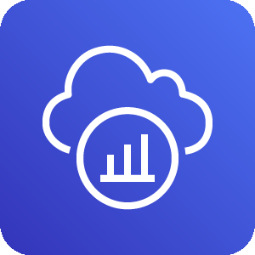  X-Ray | X-Ray is a powerful tracing, debugging, and performance analysis tool that helps developers visualize application behavior. With X-Ray, developers can quickly identify performance bottlenecks, troubleshoot issues, and optimize applications for better efficiency and reliability.

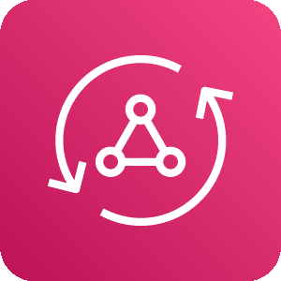  AppSync | AWS AppSync is a fully managed GraphQL service. With AWS AppSync, developers can create a single GraphQL API that can securely access, manipulate, and combine data from multiple data sources. This helps developers connect frontend applications with backend data.

With GraphQL, a query language for APIs, clients request only the specific data they need.

  Amplify | Amplify helps you streamline the process of developing, deploying, and managing secure and scalable full-stack applications on AWS. With Amplify, developers can quickly add features, like authentication, APIs, storage, and hosting, with minimal infrastructure management.

Full-stack applications are software systems that involve both frontend (user interface) and backend (server-side) development.

Business Application Services

  Amazon Connect | Businesses can use this AI-powered contact center service to efficiently set up and operate a scalable customer service call center. Amazon Connect provides capabilities for call routing, recording, and analytics while integrating seamlessly with other AWS services.

  Amazon Simple Email Service | Amazon SES is a scalable and cost-effective email service provider that can be integrated into any application for reliable, high-volume email automation. It helps businesses optimize the delivery of transactional and marketing emails, resulting in enhanced customer engagement.

End-User Computing Services

In modern businesses, IT departments often need to provide remote access to resources like virtual desktops and applications. These services help you do that:

  AppStream 2.0 | AppStream 2.0 is a fully managed service that streams applications from the cloud directly to any compatible device. This includes software-as-a-service (SaaS) applications and applications converted from desktop to SaaS without code revisions. This provides instant access to powerful software without the need for high-end local hardware.

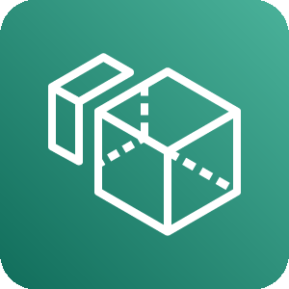  Amazon WorkSpaces | WorkSpaces is a fully managed cloud-based desktop computing service. With WorkSpaces, employees can securely access their work environment from any device with an internet connection. Employees can perform the same tasks as if they were on a physical office computer, while companies can benefit from cost-efficiency and easy administration.

⚠ WHAT YOU MISSED — Know This for the Exam
- CodeCommit and CodeDeploy: CodeCommit = AWS's managed Git repository (like GitHub hosted on AWS). CodeDeploy = automates code deployments to EC2, Lambda, or ECS. Together with CodePipeline and CodeBuild they form the full AWS developer toolchain.
- SageMaker vs Bedrock — exam distinction: SageMaker = for ML engineers who need to build, train, and fine-tune their own models with full control. Bedrock = for developers who want to call powerful pre-built foundation models via API with no ML expertise needed. The exam asks: who needs custom training → SageMaker. Who needs fast FM access → Bedrock.

 MODULE 13 The Cloud Journey

AWS Well-Architected Tool

  AWS Well-Architected Tool | The AWS Well-Architected Tool (AWS WA Tool) is a free service that helps assess and improve cloud workloads based on the six key pillars: Operational Excellence, Security, Reliability, Performance Efficiency, Cost Optimization, and Sustainability. It offers workload reviews, milestone tracking, and custom lenses for tailored evaluations and improvement plans. Integrated with AWS services like AWS Identity and Access Management (IAM) and APIs, it supports team collaboration and continuous progress tracking. The AWS WA Tool is ideal for architects, engineers, and compliance teams, and it promotes consistent, actionable, and well-documented architecture reviews.

Pillar | What It Focuses On
Operational Excellence | Running and monitoring systems to deliver business value and continuously improving processes and procedures.
Security | Protecting information, systems, and assets while delivering business value through risk assessment and mitigation.
Reliability | The ability of a system to recover from failures, dynamically meet demand, and mitigate disruptions.
Performance Efficiency | Using computing resources efficiently to meet system requirements as demand changes and technology evolves.
Cost Optimization | Avoiding unnecessary costs and understanding where money is being spent across your workloads.
Sustainability | Minimizing the environmental impacts of running cloud workloads through energy efficiency and shared resources.

⚠ WHAT YOU MISSED — Know This for the Exam
- Well-Architected pillars on the exam: Know which pillar a given scenario belongs to. Multi-AZ and backup strategies = Reliability. Encryption and least-privilege = Security. Right-sizing and reserved instances = Cost Optimization. Auto Scaling and CloudWatch = Performance Efficiency + Operational Excellence.
- CloudFormation: IaC service — define your entire AWS infrastructure as a YAML or JSON template. CloudFormation provisions and manages it for you automatically. Enables repeatable, version-controlled, and auditable infrastructure deployments.
- IaaS vs PaaS vs SaaS on AWS: IaaS examples: EC2, VPC, EBS (you manage OS and up). PaaS examples: Elastic Beanstalk, Lambda (you manage code only, AWS handles the rest). SaaS examples: Amazon Connect, Amazon WorkSpaces, AWS Marketplace software (fully managed, vendor runs everything).
- The exam is conceptual: You don't need to know HOW to configure services. You need to know WHAT each service does, WHEN to use it, and WHY it's better than alternatives in the scenario. Focus on service purpose and the use cases AWS uses to describe each one.

AWS Cloud Practitioner Essentials
EXAM GUIDE — EVERYTHING YOU NEED TO KNOW

Questions | Duration | Passing Score | Max Score | Price | Format
65 | 90 min | 700 / 1000 | 1000 | $100 | Multiple Choice + Multi-Response

Exam Domains & Weights

Domain | Weight | What It Tests
Cloud Technology & Services | 34% | EC2, S3, RDS, Lambda, VPC, CloudWatch, ELB — the core AWS services and how they work.
Security & Compliance | 30% | IAM, Shared Responsibility Model, Shield, WAF, KMS, ACM, Organizations, compliance services.
Cloud Concepts | 24% | Benefits of cloud, pricing models, AWS Global Infrastructure, migration strategies, CAF.
Billing, Pricing & Support | 12% | Pricing Calculator, Cost Explorer, Budgets, support plans (Basic/Developer/Business/Enterprise).

How the Scoring Works

The exam uses a scaled scoring system from 100 to 1000. The passing score is always 700. There is NO PENALTY for wrong answers — always answer every question, even if you have to guess. Multi-Response questions (select TWO or THREE) require ALL the correct answers to earn credit — no partial credit.

Key Test-Taking Strategies

- Look for keywords: "most cost-effective", "highly available", "most secure", "minimum operational overhead" — these words tell you EXACTLY which service or answer to pick.
- Eliminate wrong answers first: Usually 2 of the 4 options are clearly wrong. Focus on the remaining 2 and pick the one that best fits the scenario.
- Managed service preference: AWS almost always prefers MANAGED services over unmanaged ones when asking "what is the best approach". E.g., RDS over running your own DB on EC2.
- Shared Responsibility Model: Almost every security question relates back to this. AWS = hardware/infrastructure. You = data, OS, network config. Know it cold.
- Read the full scenario: Pay attention to scale (millions of users vs 100 users), frequency (real-time vs batch), and cost constraints — they change the correct answer.
- Flag and review: You can flag questions to return to. Don't spend more than 90 seconds on one question — flag it and move on.
- This exam is conceptual: You don't need to know HOW to configure services. You need to know WHAT each service does, WHEN to use it, and WHY it's better than the alternatives.

